**BLOG APPLICATION**

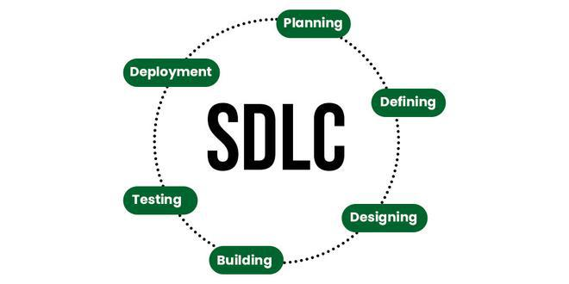

**Planning**

This blog application will be a website where users can read, write, and comment on blog posts. Users can create accounts, log in, and manage their posts. An admin approves comments to ensure they are appropriate. The site provides a RESTful API for programmatic interactions.

**Defining**

This blog application is a website where people can read, write, and comment on articles or blog posts.

### **Key Features:**

1. **Reading Posts:**
   * You can browse a list of blog posts on the homepage.
   * Click on a post to read the full content.
2. **Writing Posts:**
   * If you have an account and are logged in, you can write your own blog posts.
   * You can also edit or update the posts you’ve written.
3. **Commenting:**
   * Each blog post has a comment section where readers can leave their thoughts or feedback.
   * Comments need to be approved by an admin before they appear publicly.
4. **User Accounts:**
   * Users can sign up for an account and log in.
   * Logged-in users can write and edit their posts.
5. **Admin Panel:**
   * There is a special admin area where administrators can manage the blog posts and comments.
   * Admins approve comments to make sure only appropriate ones are displayed.
6. **API:**
   * The application also provides an API (Application Programming Interface) which allows other software to interact with the blog, like getting posts or adding comments through code.

**Designing**

* **Front-end:** HTML, CSS, JavaScript for the user interface.
* **Back-end:** Django views and templates.
* **API:** REST API to manage posts, comments, and users.
* **Database:** Models for posts, comments, and users.

#### **Steps:**

1. Set up a Django project and create a basic blog model.
2. Create views to handle creating, reading, updating, and deleting blog posts.
3. Use Django forms for handling user input.
4. Add user authentication and authorization.
5. Create RESTful API endpoints using Django REST Framework.
6. Implement front-end features using JavaScript and AJAX.

Reference Website

[Blogging Platform using Django - GeeksforGeeks](https://www.geeksforgeeks.org/blogging-platform-using-django/)

[Building A Blog Application With Django (djangocentral.com)](https://djangocentral.com/building-a-blog-application-with-django/)

